

**Winter 21 Newsletter**

**Winter Newsletter 2021**



**STAFF TRAINING & BANK HOLIDAY CLOSURE DATES**

The Surgery will be closed on

**Bank Holiday Monday 27.12.21**

**28.12.21**

**03.01.22**

and closed for staff training from13.00 on: **Wednesday 08.12.21 Thursday 10.02.22**

And closed for staff

Meeting on

**Wednesday 12th January 2021 between 2pm and 4pm**

The phone lines will still be answered.

**WHEN THE SURGERY IS CLOSED YOUR CALL WILL BE DIVERTED TO NHS 111. THE PHONELINE REMAINS OPEN DURING OUR STAFF MEETING**

**STAFF NEWS**

We welcome to the team:

**Care Navigators** Caitlin Smyton

**GP’s**

Dr Jafar Shahabi

Dr Mohammad Jubayer

**Nurses**

Nora For-Szabo

**Administrators**

Natalie Cheney

Covid Boosters are still underway. Book your appointment now! We hold various clinics, including weekends, across all of our branches. Please book online, or call us to get your appointment if you are due.

If you are still in need of a flu vaccine, it is not too late to get booked in. Book online or call us to arrange an appointment.

Our Primary Care Network (PCN)

The PCN is network of surgeries in the area that work together to give patients the best care.

**Pharmacist Team –** The Pharmacists can call you to fulfill outstanding medication reviews or even help with medication queries.

**Physio Team –** We have physios who can offer appointments to our patients.

**Patient Coordinators -** they may call you to organize appointments/group consultations or collate referral information.





The dispensaries at Alderton & Orford are now serving from the hatch inside the surgery. We would like everyone to maintain social distancing where possible and everyone entering the surgery must wear a face mask unless exempt.

If you do not pay for prescriptions, could patients kindly bring proof of exemption for prescription payment.

We would like to welcome our new staff! Caitlyn has joined the care navigators’ team, Dr Shahabi and Dr Jubayer has joined the GP team, Nora has joined the nursing team and Natalie has joined the Admin team. We look forward to working with them. We also welcome Sophie Walker, who is a PCN Patient Coordinator that will work with the practice.



[www.thepeninsulapractice.co.uk](http://www.thepeninsulapractice.co.uk/)

01394 411641

**Patient Participation Group (PPG)**

The PPG is a made up of volunteer patients who are involved in supporting

the surgery to provide the services to all our patients.

It helps facilitate good relations between patients & the Practice by communicating patients’ experience, interests and concerns and by providing feedback from the Practice on current procedures and proposed new developments.

If you would like to contact the PPG directly please email:

[peninsulapracticeppg@gmail.com](mailto:peninsulapracticeppg@gmail.com)

**APPOINTMENTS MISSED**

In total 105 appointments were not attended between August - October.

Aldeburgh = 45

Alderton = 40

Orford = 19

Hollesley = 1

**Please be aware that the information in this newsletter is correct at time of going to print.**

**\*\*\*\*\*\*\*\*\*\*\*\*\*\*\*\*\*\*\***

**Merry Christmas and a Happy New Year!**

**Medical Research**

NHS research is essential to help shape and improve future NHS healthcare. The Peninsula Practice has been involved in cutting edge national research including a new device to replace endoscopy in some cases.

Dr Crockett is the principal investigator for all research at the practice, whereby she checks eligibility for patients to take part in relevant studies. You may therefore receive an invitation, which will be directly from The Peninsula Practice, to participate in a study - we never share your personal details. You are free to choose whether to take part or not with no obligation. Taking part in clinical research may benefit you, or others like you, in the future.

For more information about the research projects we are involved in please visit our website: [**www.thepeninsulapractice.co.uk/research**](http://www.thepeninsulapractice.co.uk/research)

**Stay Well this Winter**

Cold weather can make some health problems worse and even lead to serious complications, especially if you are 65 or older, or if you have a long-term health condition. For information and advice to stay well at winter, please visit

**https://www.nhs.uk/live-well/healthy-body/keep-warm-keep-well/**



**Citizens Advice**

Citizens Advice provides free, confidential, impartial and independent advice to help people overcome their problems and find a way forward whatever difficulties they face. Advice on issues such as debt, budgeting, benefit, housing or employment problems.

**Citizens Advice holds regular clinics at The Peninsula Practice. Please ask at reception for more information or visit** [**https://www.citizensadvice.org.uk/**](https://www.citizensadvice.org.uk/) **or call 01728 832193**

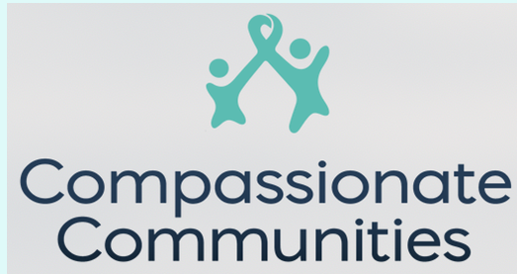

**Compassionate Communities**

Compassionate Communities is part of a local project to support living life fully before we die, providing companions for people and families affected by life-limiting illness, and starting conversations about end of life. To find out more, visit https://www.compassionate-communities.co.uk/



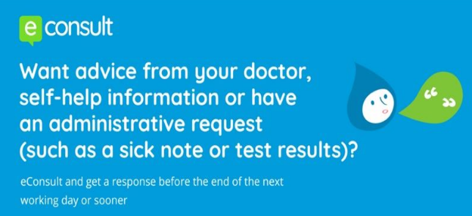

[www.thepeninsulapractice.co.uk](http://www.thepeninsulapractice.co.uk/)

01394 411641